Heather Cox Richardson, Twitter thread, Sep. 2016

When we levy taxes, we are deliberately shaping society. The question is... what society are we shaping? 1/
Before the Civil War, the US had no national taxation because southern slave holders kept the government small and inactive. They wanted no interference with slavery + wanted money to accumulate in their hands, so they could advance "progress." A few tariffs funded government./2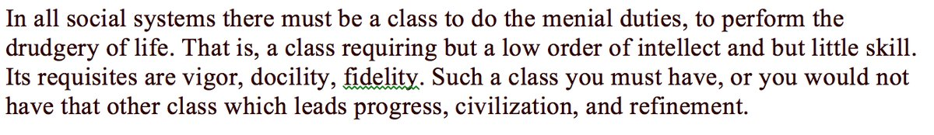
Republicans under Lincoln believed that progress came from regular folks, so they created an active government to promote opportunity. That meant new systems of funding, including taxation. In 1861, GOP invented national taxation, and in 1862, the graduated income tax. /3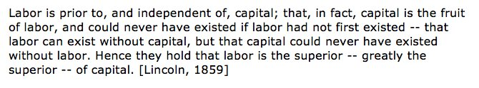
This paid for the Civil War and for new departments to spread opportunity. It tied individuals to the government, spread costs fairly, and was enormously popular. As a war measure, it was set to expire in 1872, but got extended until 1875. Then funding went back to tariffs. /4
New GOP tariffs protected industry, whose leaders colluded to raise prices. This hurt workers. Money moved upward. Democrats begged for lower tariffs to lower prices for workers, but GOP said no, the gov't needed funding. (It actually ran a SURPLUS in the late 1880s). /5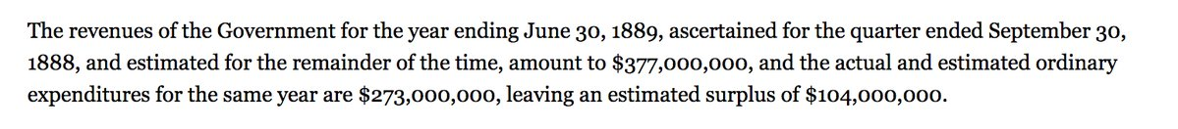
When the economy crashed in 1893, Democrats in Congress passed an 1894 law lowering tariffs and levying a new income tax on rich. Pro-big business Supreme Court declared income tax unconstitutional in 1895: only states could tax (Pollock v Farmers' Loan). News to Republicans! /6
This meant rich didn't have to support government, even as they were awash in money (In 1901, J.P. Morgan's US Steel was capitalized at $1.4 billion; 3 times national budget). In 1909, GOP President William H. Taft called for constitutional amendment permitting income tax./7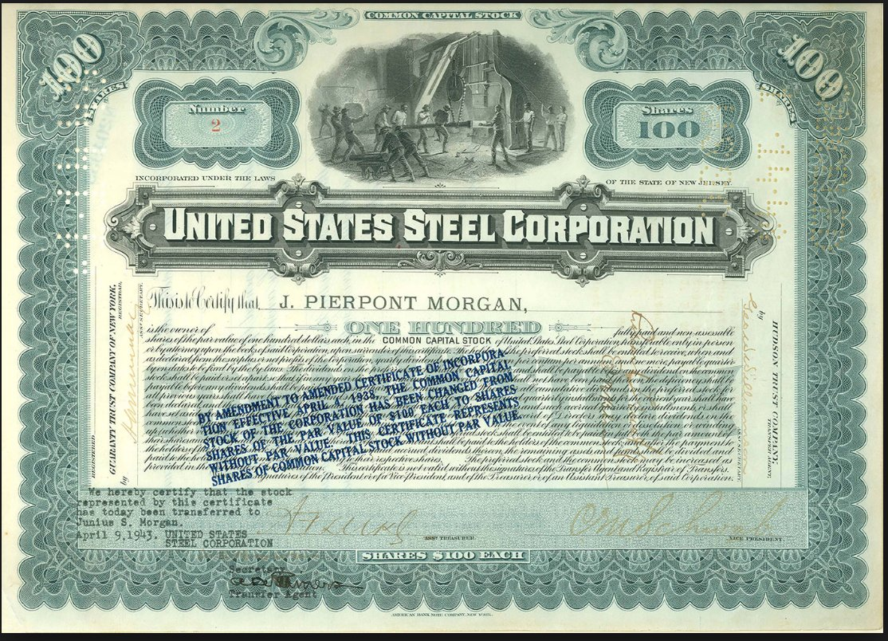
1913: Sixteenth Amendment. D President Woodrow Wilson instantly proposed cutting tariff and replacing money w/ tax: the Revenue Act of 1913. (This is often incorrectly cited as the first income tax.) Then WWI hit, and taxes went as high as 77% to pay for it. /8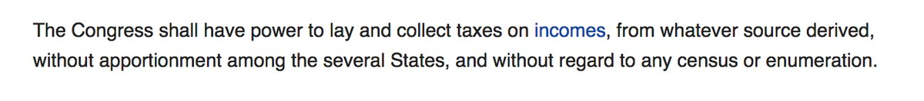
After 1918, Treasury Secretary Andrew Mellon went on campaign to slash those taxes because he believed they were killing growth. It worked, but fed the 1920s bubble that led to the 1929 Crash. Then, FDR's New Deal raised taxes on wealthy and created the modern activist state./9
That introduced a new wrinkle. Movement Conservatives (like Goldwater) hated the New Deal state and wanted to slash taxes to destroy it. Other GOPers, like Eisenhower, wanted to pay off WWII's debt. DDE kept high tax rate at 91%. Goldwater=apoplectic. Called DDE a socialist. /10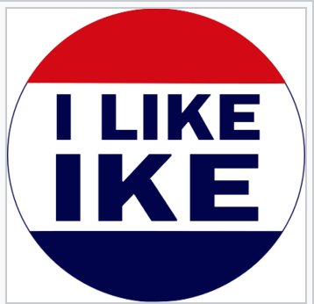
To undercut Goldwater and a short-term recession, JFK proposed a 1963 tax cut. Passing Congress in 1964, it ended GOP debt payoff plan. Often used as proof that tax cuts stimulate economy, it actually cut taxes primarily on the demand side (workers) not supply-side (the rich)./11
Movement Conservative Reagan set GOP on path to destroy the New Deal gov't. He slashed taxes in 1981 and 1986 on ground that freeing up $$ on the supply side would stimulate economy. Budget director David Stockman admitted this was just "trickle down" economics in a new guise./12
Reagan economy boomed from cheap oil, dropping interest rates, huge deficit spending for the military, deregulating the savings and loan banks, but idea spread that tax cuts worked to pump the economy. The cuts instead started the Great Divergence, moving $$$ upward. /13
Tax cuts to destroy the New Deal state became a political law for GOP, even though folks like government programs. Leaders convinced voters that gov't programs gave tax dollars from hardworking white men to lazy POC and women. GWBush slashed taxes and programs. So has Trump./14
But both also poured money into military. Taxes on rich went down; benefits went down. Nat'l debt and living costs went up. So gov't is still pricey, but $$ goes to contractors and investors, not regular folks. CBO says cuts won't pay for themselves. /15
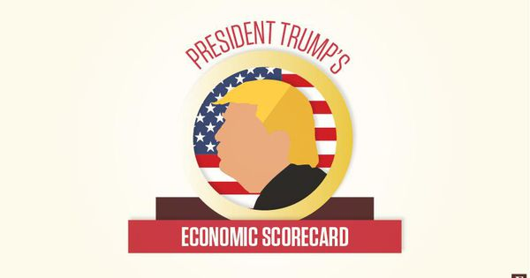
Trump's Federal Budget Deficit: $1 Trillion And BeyondThere are very different views between the Trump administration and non-partisan organizations on the trajectory of yearly U.S. deficits.https://bit.ly/2QdUQ2D
At the end of the day, a government that protects us, guarantees we don't have to eat of garbage cans, and fixes our bridges costs money. And now we have a HUGE debt that must be paid. Who should do it? That's what tax policy is about./16
Do we think that a few rich folks should have all the money because they know best how to run society? That's what we're saying these days. Or should we balance taxes so that we all pay our fair share and all have a stake and a say in our government? Me, I'm #TeamLincoln /END

